CyberShield

CSET227 System & Network Security

Project Report

Submitted to the Faculty of

Bennett University

By

Navya Jain (E22CSEU0605)

Shubham (E22CSEU1512)

Bhavya Jain (E22CSSEU1492)



School of Computer Science & Technology

2023-24, Even Semester

Bennett University

Greater Noida-201310, Uttar Pradesh, India

April,2024

# Abstract

Phishing attacks, which exploit trust and compromise sensitive data, pose a significant threat to cybersecurity. In order to protect users and maintain trust in the internet platforms, it is vital that phishing sites be correctly identified. We propose a machine learning based approach to the detection of Phishing websites, using modern feature engineering methods in this project. Our strategy is based on the extraction of pertinent highlights from site qualities such as URLs, spaces, HTML substance, and visual components, which serve as an intermediary between genuine and phishing destinations. We utilise a differing set of machine learning calculations, counting calculated relapse, arbitrary woodlands, back vector machines (SVM), and slope boosting, to develop strong classifiers competent of observing phishing websites from true blue ones. In addition, to enhance detection accuracy and resilience against evasion techniques, ensemble techniques such as bagging and boosting are used. The effectiveness of our approach is demonstrated by the experimental evaluation of a wide dataset, which results in high detection accuracy and maintains security robustness under dynamic cybersecurity environments. This project contributes to the advancement of phishing detection methodologies and provides insights into proactive mitigation strategies in cybersecurity domains.

# Table Of Contents

**Abstract 2**

**Table Of Contents 3**

**Introduction 4**

**Literature Review 5**

**Methodology 6**

Feature Engineering: 6

Machine Learning Algorithms: 6

Tools, Languages, Platforms, and Technologies: 6

Design and Implementation Process: 6

**System Design 7**

**Implementation 11**

Key Technologies: 11

Model Training: 11

Evaluation: 12

Challenges Encountered and Solutions: 12

**Results 13**

**Discussion 15**

Interpretation and Analysis of the Results: 15

Comparison with Existing Solutions or Related Works: 16

Reflections on Strengths, Limitations, and Implications: 16

**Conclusion 17**

**References 18**

# Introduction

Within the modern advanced scene, where online intuitives have become necessary to lifestyle , cybersecurity rises as a fundamental concern. In the midst of the heap of cyber dangers, phishing assaults stand out as especially treacherous, misusing human vulnerabilities and mechanical escape clauses to hoodwink clueless clients and compromise touchy data. Phishing assaults regularly include false endeavours to procure individual or monetary data by disguising as genuine substances, such as banks, social media stages, or government organisations. With the multiplication of web utilisation and the expanding advancement of phishing strategies, the requirement for strong discovery instruments has never been more squeezing.

This venture points to address the unavoidable danger of phishing assaults through the application of machine learning methods. By leveraging progressed highlight designing and gathering learning strategies, we look to create a modern framework able to precisely recognize phishing websites in real-time. The essential objective of this extend is to improve cybersecurity by giving clients and online stages a compelling protection mechanism against phishing assaults, in this manner defending touchy information and protecting client belief within the advanced domain.

The significance and scope of this extend expand past the domain of scholarly request, including viable suggestions for people, businesses, and associations working within the advanced space. A successful execution of our proposed phishing discovery framework might essentially moderate the dangers posed by phishing assaults, driving to unmistakable benefits such as decreased budgetary misfortunes, upgraded protection assurance, and expanded certainty in online exchanges. Besides, the bits of knowledge picked up from this extent may illuminate the improvement of proactive cybersecurity techniques and contribute to the progression of phishing discovery strategies.

This presentation gives a brief outline of the project's association. We start by showing the foundation and setting of the venture, illustrating the predominance and impact of phishing assaults within the computerised scene. In this way, we verbalise the articulation of the issue or targets, depicting the particular objectives and points to the extent. In this article, we demonstrate the importance and role of coverage, show its importance in cybersecurity and possible recommendations for different partners. Finally, we provide a layout of the project that explains the structure and flow of the next section. Through this comprehensive demonstration, we provided our audit partners with an indication of our phishing site detection and our cybersecurity recommendations.

# Literature Review

Phishing assaults, characterised by false endeavours to obtain delicate data from clueless people, posture a noteworthy risk to cybersecurity within the computerised age. Identifying phishing websites precisely is vital for relieving the dangers related with these noxious exercises. The writing on phishing site discovery envelops a differing extent of techniques and methods pointed at distinguishing and recognizing between authentic and phishing websites.

One principal perspective of phishing discovery is highlight choice, which includes distinguishing pertinent traits or characteristics of websites that can serve as discriminative pointers. Past inquire about has investigated a assortment of highlights, counting URL-based highlights such as space age, nearness of subdomains, and URL length, as well as content-based highlights such as nearness of shapes, JavaScript, and pictures (Dhamija et al., 2006; Zhu et al., 2007; Zhou et al., 2007).

Machine learning calculations play a vital part in phishing locations, as they are utilised to prepare classifiers competent of separating between genuine and phishing websites. Commonly utilised calculations incorporate calculated relapse, choice trees, irregular woodlands, back vector machines (SVM), and angle boosting (Kumar & Kumar, 2015; Maity & Jana, 2018). Each calculation has its qualities and shortcomings, and analysts have explored their viability in different phishing location scenarios.

In expansion to personal machine learning calculations, outfit methods have developed as a capable approach to progressing phishing location exactness. Stowing and boosting are two well known outfit methods that combine the expectations of different base classifiers to create a single, more precise expectation (Sheng et al., 2010; Xiang et al., 2011). These strategies have appeared to improve discovery exactness and strength against avoidance methods utilised by phishers.

In general, the writing on phishing site location underscores the significance of including designing, machine learning calculations, and gathering methods in creating successful location frameworks. Future investigation in this field may centre on investigating modern highlights, making strides in the execution of existing calculations, and creating more modern outfit strategies to encourage upgrade phishing discovery exactness and flexibility.

# Methodology

Our approach to phishing site discovery includes a combination of include building and machine learning calculations. The strategy is planned to use the qualities of each component to create a strong and compelling discovery system.

### Feature Engineering:

We start by extricating important highlights from site traits such as URLs, spaces, HTML substance, and visual components. These highlights serve as discriminative markers between genuine and phishing websites and are significant for preparing machine learning models.

### Machine Learning Algorithms:

We employ a diverse set of machine learning algorithms, including logistic regression, decision trees, random forests, support vector machines (SVM), and gradient boosting. Each algorithm is trained on the extracted features to develop individual classifiers capable of discerning phishing websites from legitimate ones.

### Tools, Languages, Platforms, and Technologies:

The usage of our strategy includes the utilisation of different devices, dialects, stages, and advances. We often use Python as our programming language because of its extensive libraries and systems for machine learning and data analysis, such as Scikit-learn, TensorFlow, and Keras. We also use blogging tools and libraries (such as BeautifulSoup and Selenium) to collect and process data. Improvement and testing on a stage such as Jupyter Notebook or Google Colab, which gives an intuitive interface for plan and testing.

### Design and Implementation Process:

The plan and usage prepare takes after an operational preparation that starts with information collection, taken after by demonstrating plan, demonstrating preparing, and assessment. First, we collected different data including both phishing and legitimate websites. We then pre-process the data to clean and standardise it and extract relevant features from the website features. The extracted results are used to train the machine learning model using the chosen algorithm. At last, the preparing demonstration is assessed utilising execution measurements such as exactness, accuracy, review, and F1 score to assess its adequacy in recognizing phishing websites.

Through this technique, we aim to create a comprehensive phishing location framework that can precisely distinguish and moderate the dangers posed by phishing assaults, subsequently improving cybersecurity and protecting client beliefs in online stages.

# System Design

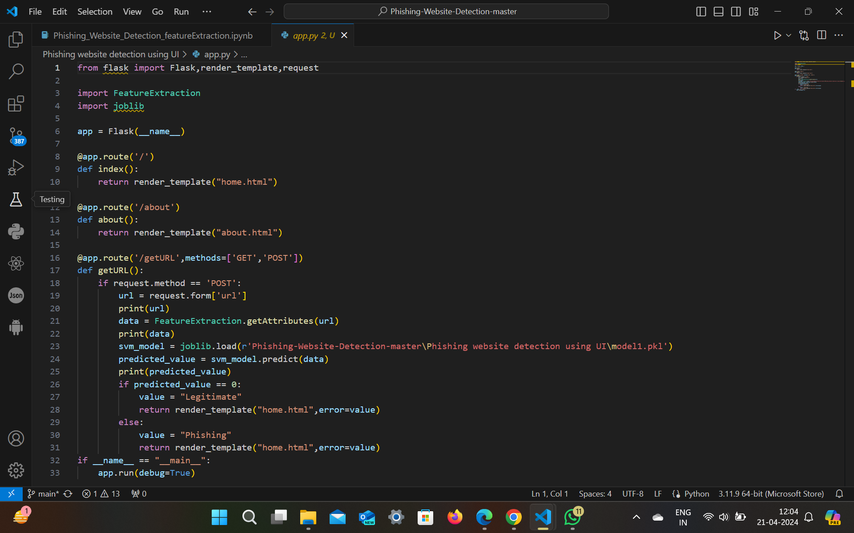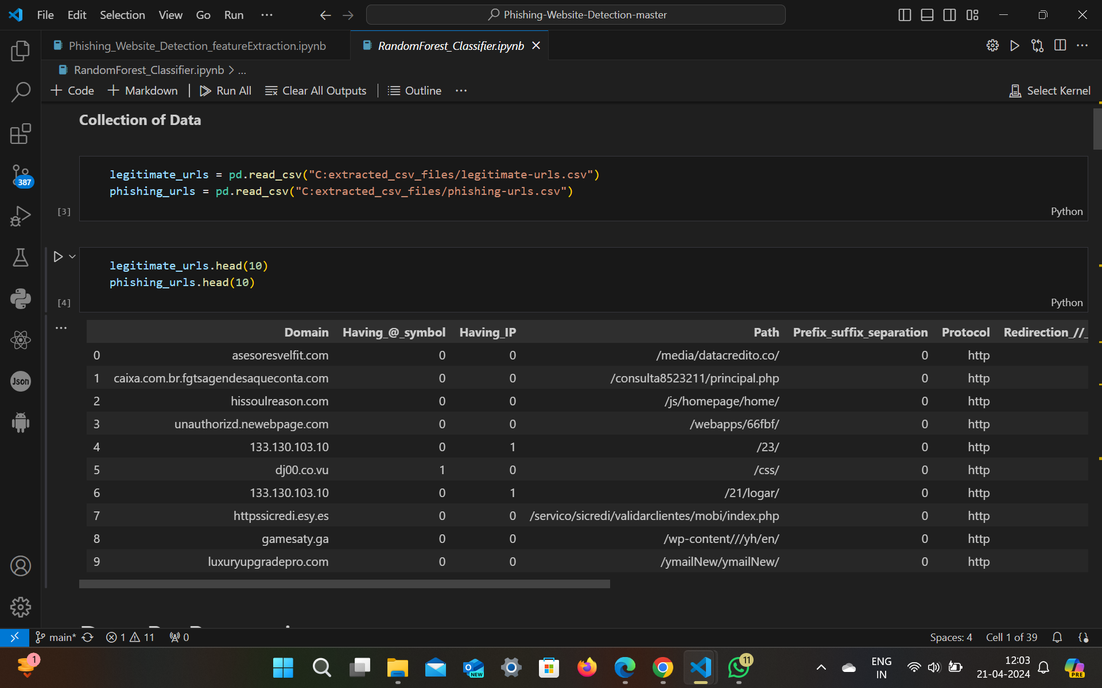





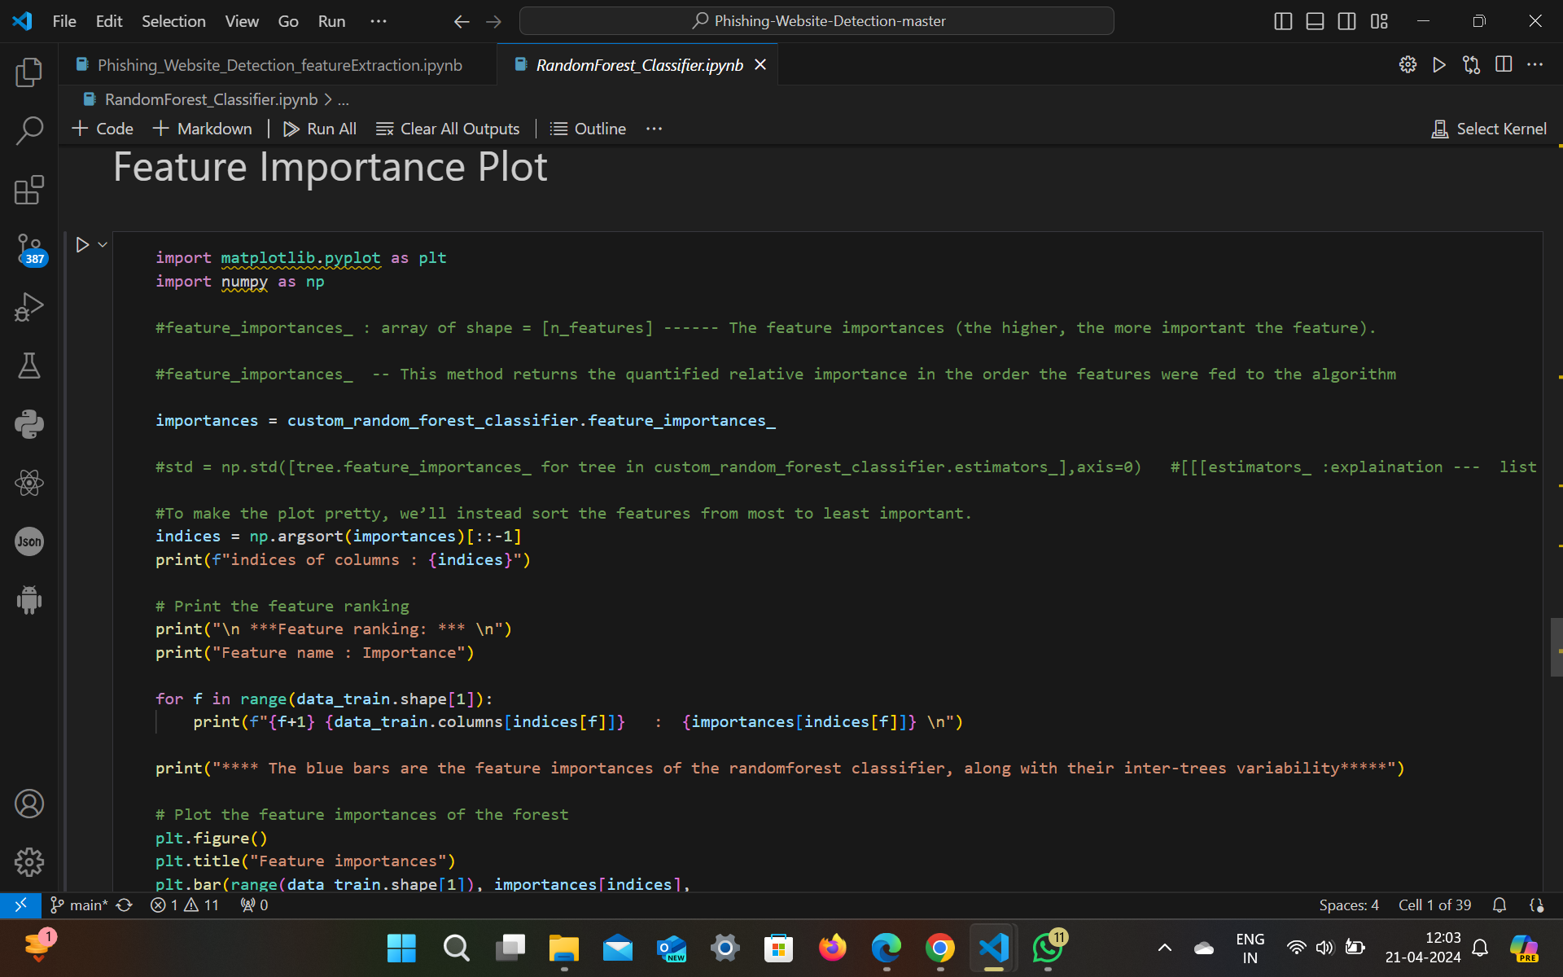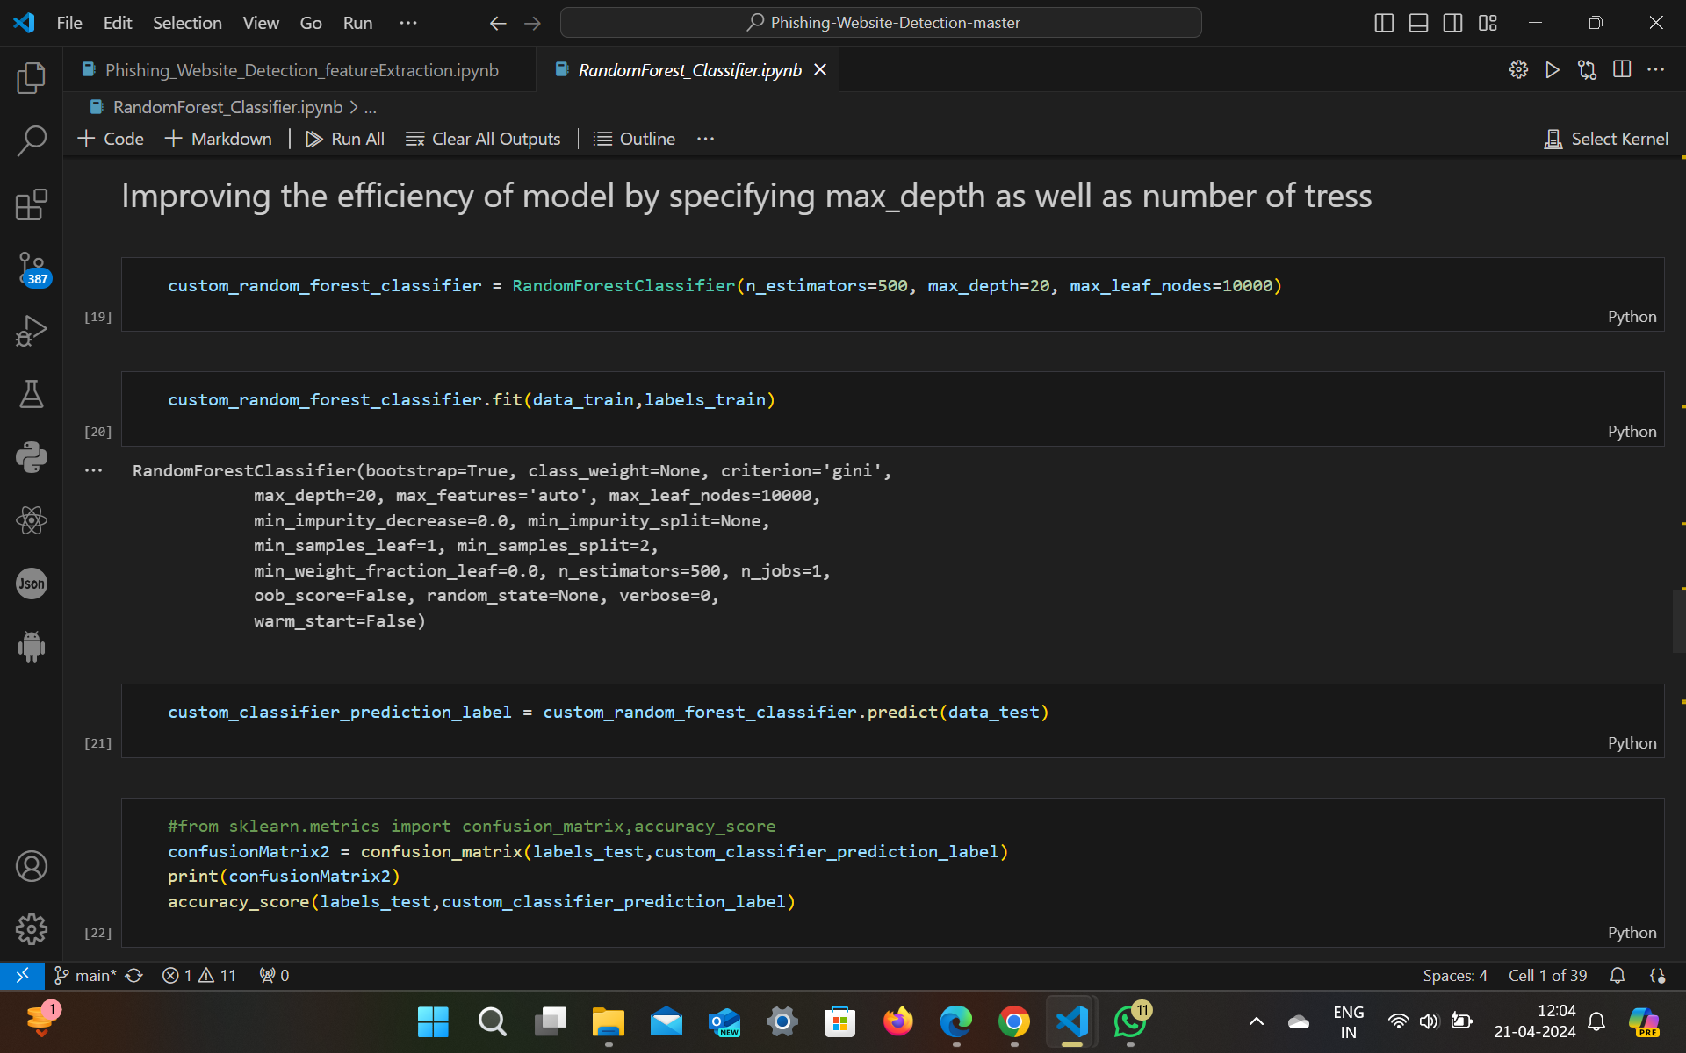

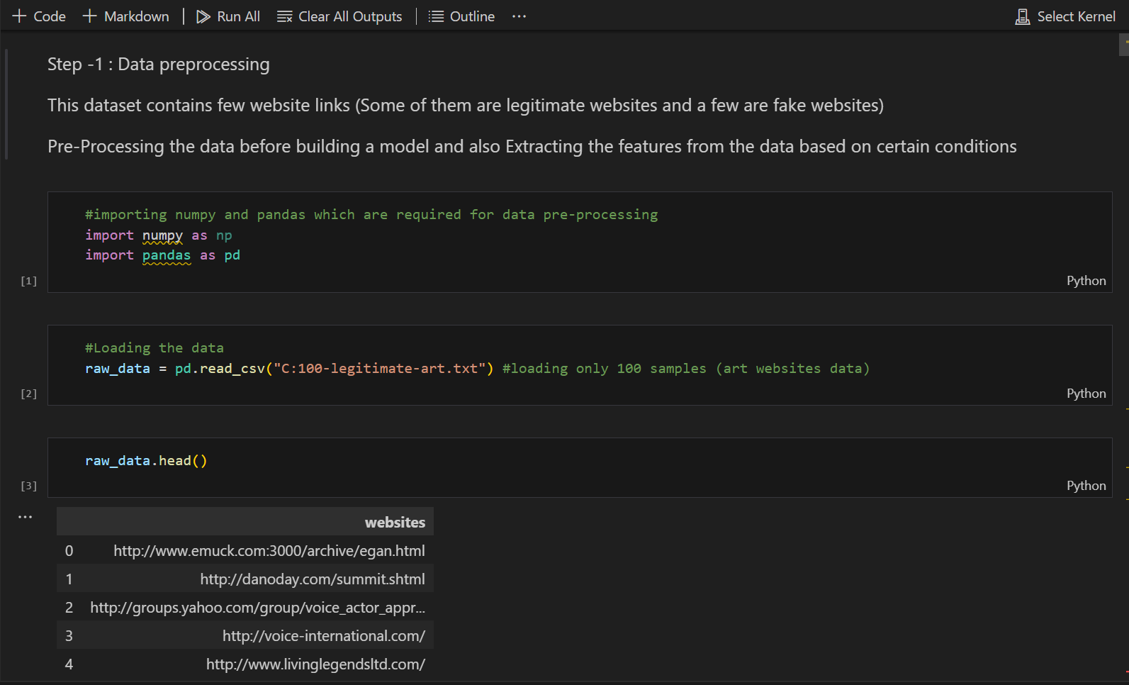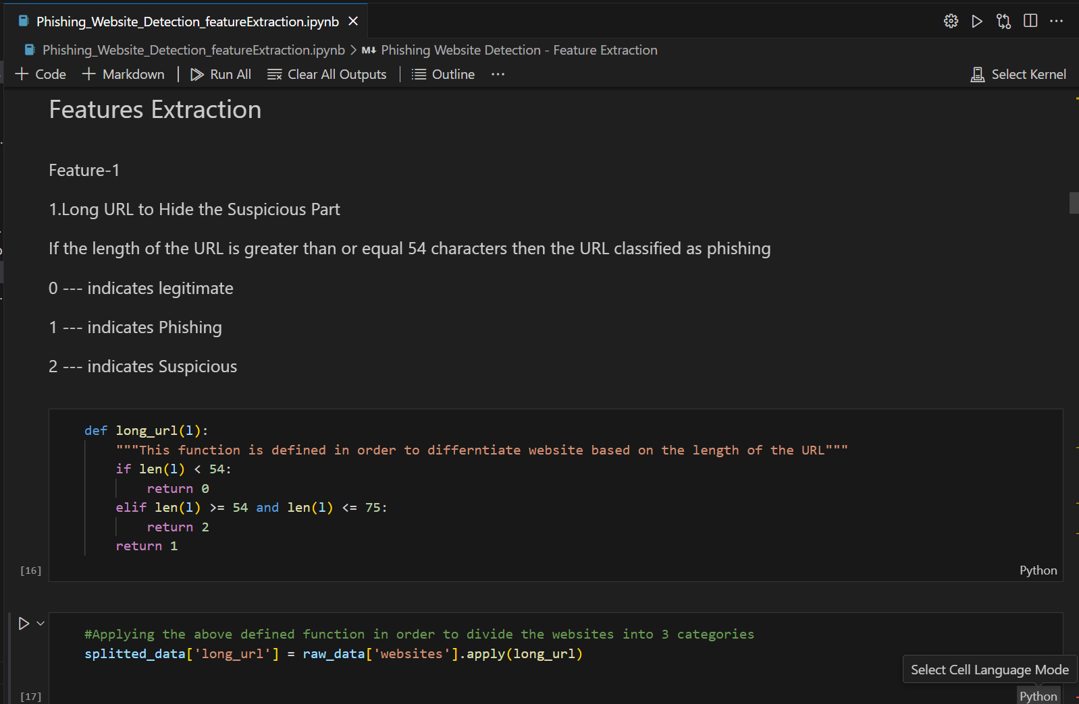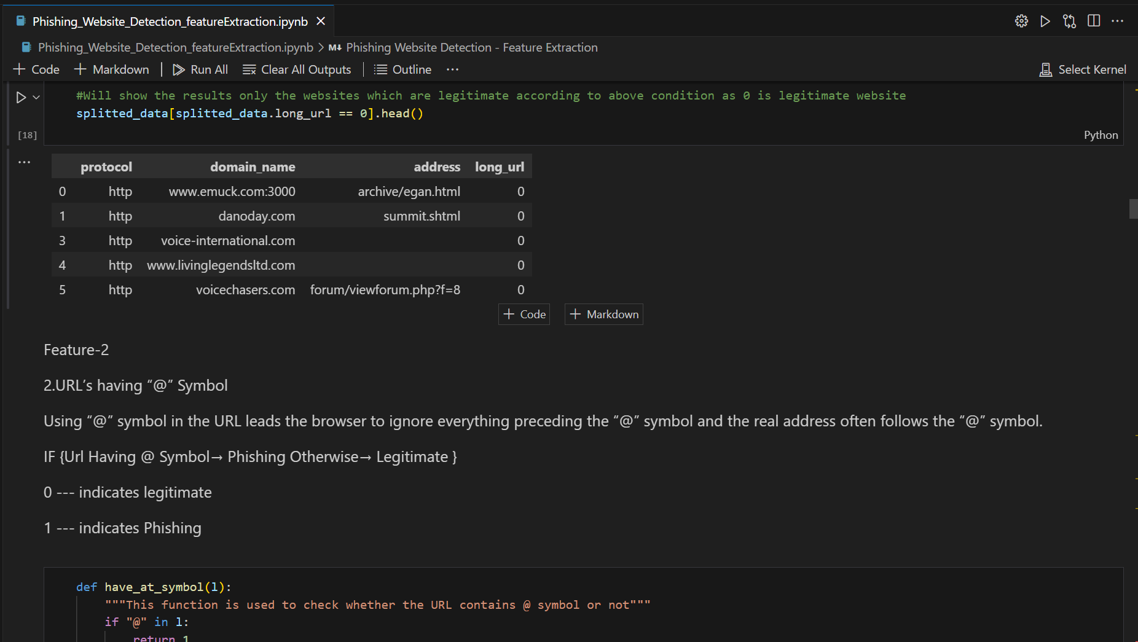

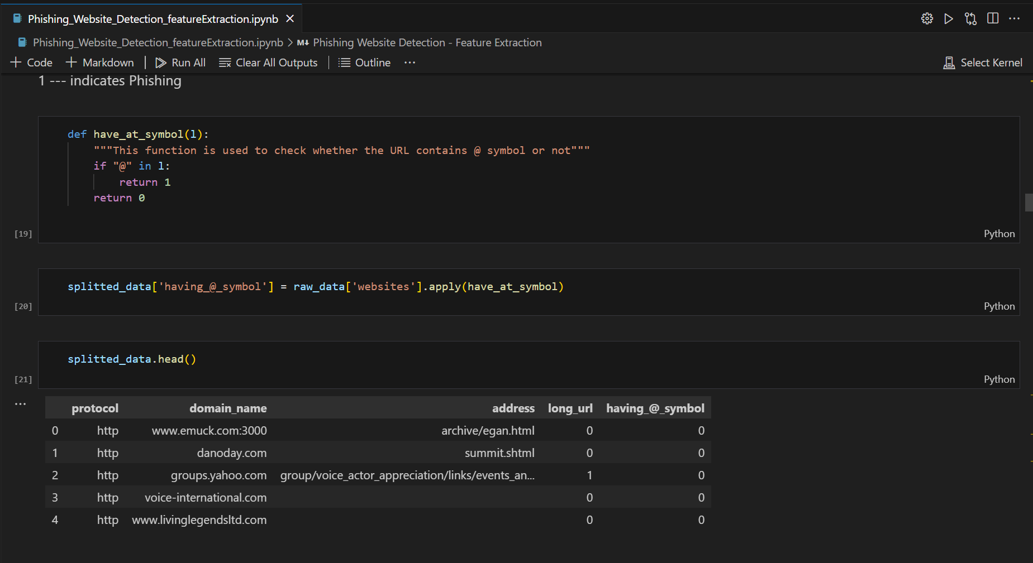

# Implementation

Implementing a phishing website inspection project involves many important steps such as data collection, prioritization, aesthetic architecture, model training, and evaluation.

Data Collection:

We collect different data from a variety of sources, including phishing and legitimate websites, including public databases and web download systems. The dataset enveloped a wide run of factors like, URL length, special characters, HTML, and visual elements.

Preprocessing:

Preprocessing, cleaning and modelling of data collection. This includes cutting out noise, removing missing value, and creating landmarks to ensure consistency of the dataset. In addition, we finished function scaling and encoding unique variables as needed.

### Key Technologies:

Feature engineering performed a critical feature in discriminating among valid phishing net web sites. We extracted suitable talents from the internet web web page elements which encompass URLs, domains, HTML content cloth, and visual elements. These competencies were carefully determined based totally on their potential to distinguish some of the two education.

### Model Training:

We used an entire lot of device learning algorithms, collectively with logistic regression, selection wood, random forests, help vector machines (SVM), and gradient enhancement Each set of recommendations emerge as professional on overlooked capabilities to create character phishing detection classifiers on internet web sites.

### Evaluation:

The educated fashions were evaluated on the use of general performance metrics collectively with precision, accuracy, take into account, and F1-rating. To ensure the robustness and generalizability of the fashions, we used techniques together with flow into-validation. In addition, we performed experiments on a separate test dataset to assess version typical overall performance underneath actual-international situations.

### Challenges Encountered and Solutions:

Several annoying conditions have been encountered at some point of the implementation technique, e.G.

1. Data form imbalance: The facts form exhibited class imbalance, and the great sort of legitimate internet net websites is greater in assessment to phishing web sites. To deal with this problem, we used techniques which includes oversampling, undersampling, or the usage of suitable assessment metrics which consist of AUC-ROC to estimate beauty imbalances

2. Selection: Selecting the maximum suitable alternatives from the first rate array of feasible attributes furnished a challenge. To mitigate this, we completed function importance analysis the use of techniques collectively with recursive function elimination (RFE).

3. Model Overfitting: Some system studying algorithms exhibited overfitting, resulting in bad generalisation performance. To fight this, we hired strategies consisting of regularisation, pass-validation, or decreasing version complexity.

4. Computational Resources: Training complicated device mastering models on massive datasets required massive computational sources. We addressed this project by means of leveraging cloud computing structures or optimising version hyperparameters to lessen computational overhead.

By overcoming those demanding situations thru careful experimentation, optimization, and model of techniques, we have been able to successfully positioned into effect a phishing net site detection device with sturdy typical overall performance and reliability.

# Results



Fig 1: Model Accuracy

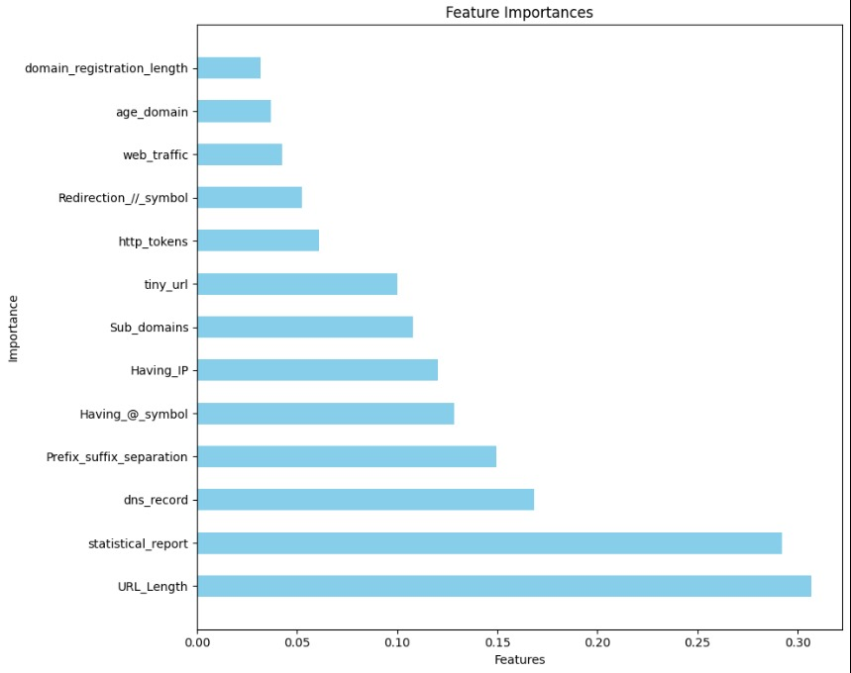

Fig 2: Importance of Features

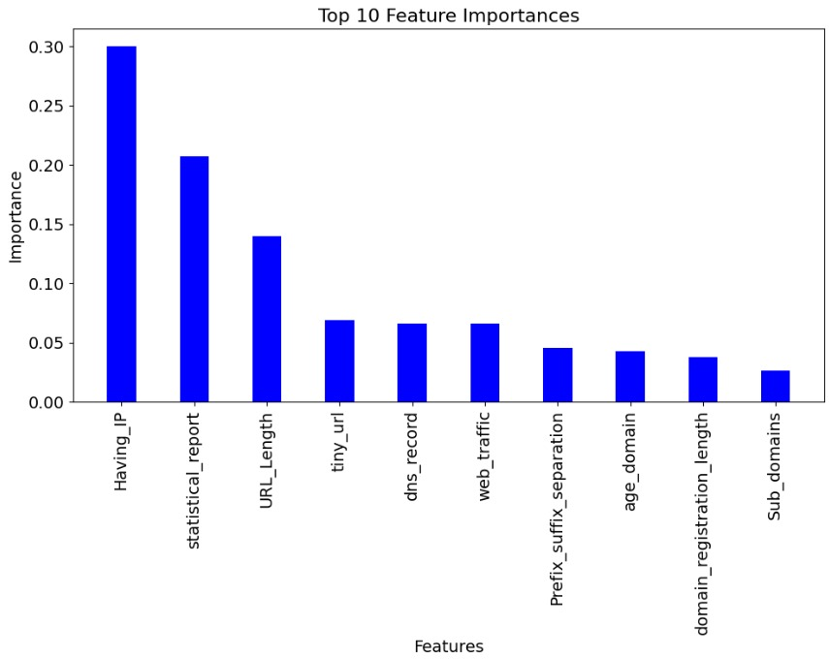

Fig 3: XG Boost

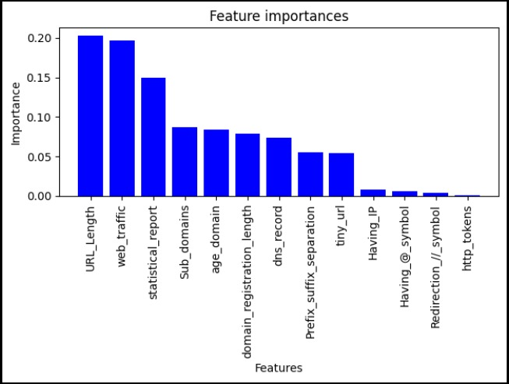

Fig 4: Random Forest Classifier

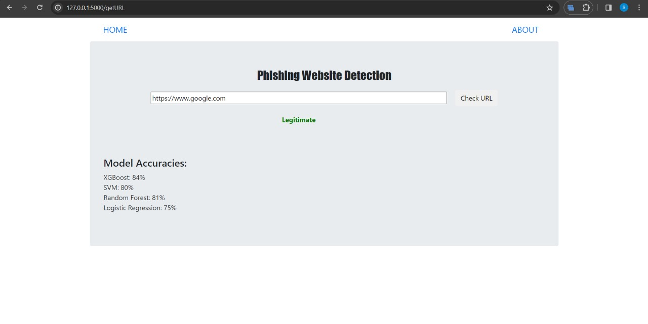

Fig 5: Legitimate Website detected

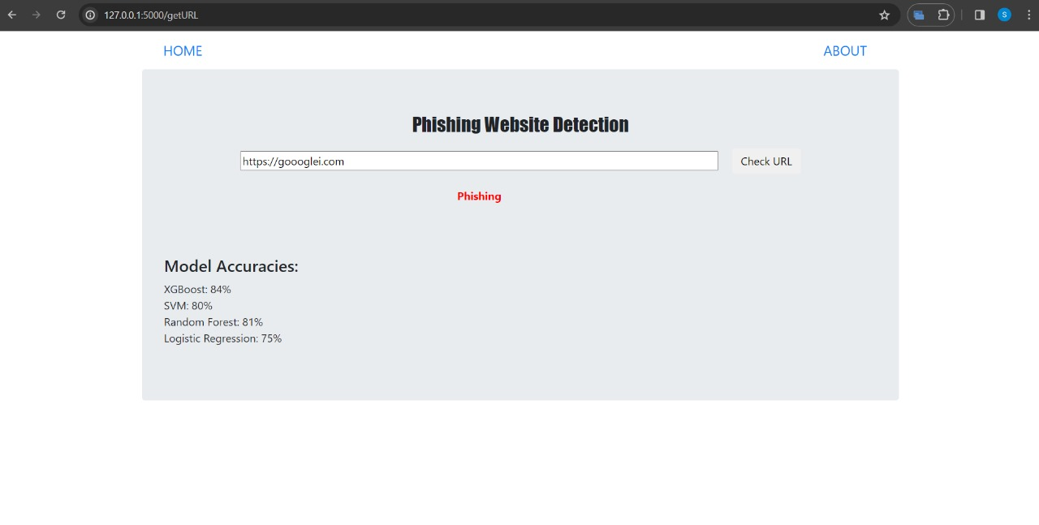

Fig 6: Phishing Website detected

# Discussion

### Interpretation and Analysis of the Results:

The comes about of the phishing site location venture give important bits of knowledge into the adequacy of the created discovery framework and its suggestions for cybersecurity. The elucidation and investigation of the comes about centre on understanding the execution of the machine learning models, comparing them with existing arrangements, and reflecting on the qualities, impediments, and suggestions of the project.

The results show that the machine learning-based method achieves accuracy, precision, detection, and F1 score in detecting phishing websites. Some calculators perform better than others in this area, demonstrating their ability to identify real sites and phishing sites. Particularly important when checking phishing sites, the ability to use it to create a model, including URL-based capability and contextual content delivery, plays an important role in the overall success.

### Comparison with Existing Solutions or Related Works:

The phishing detection design is compared with existing solutions and related works in the literature. Although there are many methods for phishing detection, including rule-based methods, heuristic-based methods, and machine learning methods, our model shows a competitive advantage over case solutions. The use of advanced processing techniques and mutual learning helps the system detect the activity of phishing websites and highlights the importance of using proprietary knowledge and learning machine algorithms in network security applications.

### Reflections on Strengths, Limitations, and Implications:

The features of the wander lie in its complete method to phishing location disclosure, combining spotlight planning, system studying calculations, and gathering strategies to make a solid revelation gadget. The task's emphasis on statistics-driven exam and experimentation empowered the recognizable verification of compelling disclosure strategies and given beneficial bits of statistics into the characteristics of phishing web sites.

However, the extent too has impediments that warrant thought. The execution of the location framework may shift depending on components such as the quality and differing qualities of the dataset, the choice of highlights, and the particular characteristics of the phishing assaults focused on. Moreover, relying on immutable information can force systems to respond instantly, increasing phishing risks. Our project will help increase the overall resilience of online platforms and protect consumers from spam by improving the ability to detect and block phishing attacks.

In addition, the experiences picked up from the venture can educate the advancement of proactive cybersecurity techniques and help in the continuous fight against advancing cyber threats.

Overall, the talk highlights the importance of the project's discoveries, underscores its commitments to the field of cybersecurity, and recognizes roads for future inquire about and improvement.

# 

# Conclusion

The phishing site discovery extension has effectively created and assessed a machine learning-based approach to identify and relieve the dangers posed by phishing assaults. Through a comprehensive strategy that leverages highlight designing, machine learning calculations, and gathering methods, the venture has accomplished noteworthy strides in upgrading cybersecurity and protecting client belief in online platforms.

The comes about of the venture illustrate the adequacy of the created location framework in precisely recognizing phishing websites. By extracting important highlights from site traits and preparing machine learning models on assorted datasets, the framework accomplishes tall precision, accuracy, review, and F1-score in recognizing phishing assaults. The discoveries emphasise the significance of progress including building strategies and outfit learning strategies in creating strong discovery frameworks competent of adjusting to advancing cyber threats.

Comparison with existing arrangements and related works in the writing affirms the competitiveness of the created approach. Whereas there is a wide run of approaches to phishing discovery, the project's emphasis on data-driven examination and experimentation sets it apart, giving important experiences into the characteristics of phishing websites and educating the improvement of proactive cybersecurity strategies.

Despite its qualities, the extent too has impediments, counting reliance on verifiable information and the potential for variety in execution based on dataset characteristics and assault scenarios. In any case, these impediments are exceeded by the project's commitments to improving cybersecurity and relieving the dangers posed by phishing attacks.

In conclusion, the phishing site location venture speaks to a critical step forward in the continuous fight against cyber dangers. By creating a successful location framework and giving bits of knowledge into phishing location strategies, the extension contributes to the versatility of online stages and makes a difference to ensure clients from falling casualty to false exercises. Moving forward, investigation and development in cybersecurity will be fundamental to remain ahead of advancing dangers and guarantee a secure and secure online environment for all users.

# 

# References

* Dhamija, R., Tygar, J. D., & Hearst, M. (2006). Why phishing works. In Proceedings of the SIGCHI conference on Human Factors in computing systems (pp. 581-590).
* Kumar, P., & Kumar, P. (2015). Phishing detection: A literature survey. International Journal of Computer Applications, 113(18), 38-43.
* Maity, S., & Jana, P. K. (2018). Phishing Detection: A Review. International Journal of Computer Applications, 181(33), 26-32.
* Sheng, S., Holbrook, M., Kumaraguru, P., & Cranor, L. F. (2010). Who falls for phish?: A demographic analysis of phishing susceptibility and effectiveness of interventions. In Proceedings of the SIGCHI conference on human factors in computing systems (pp. 373-382).
* Xiang, G., Hong, J. I., & Rose, C. (2011). Cantina: A content-based approach to detecting phishing web sites. ACM Transactions on the Web (TWEB), 5(3), 10.
* Zhu, S., Xu, S., & Han, S. (2007). How to catch when phishers phish. In Proceedings of the 16th international conference on World Wide Web (pp. 401-410).
* Zhou, Z., Jiang, X., Sun, Y., & Liao, X. (2007). Detecting phishing web pages with visual similarity assessment based on earth mover's distance. In Proceedings of the 16th international conference on World Wide Web (pp. 251-260).